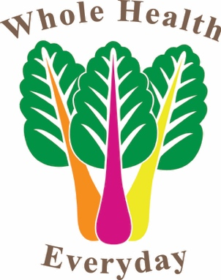

This is just a small sampling of what chef Kaylie can make for you!

WHOLE30:
Roasted Kabocha Squash, Carrot & Ginger Soup
Thai Green Papaya Salad
Spicy Lemongrass Grilled Shrimp
Sautéed Mushroom Medley with Yuzu Kosho Sauce
Sugar Snap Peas with Soffrito, Chilies, and Mint

KETO:
Grilled Artichokes with Pisco-Lime Butter
Peruvian Kale Salad with Aji-Orange Vinaigrette
Lomo Saltado (Peruvian Stir Fried Steak) with Spicy Cilantro Sauce
Sugar Free Passionfruit Pot de Creme

GLUTEN FREE:
Spicy Hearts of Palm Ceviche
Cilantro-Lime Salmon with Mango Avocado Salsa
Mexican Street Corn (Elote) with Chipotle, Cilantro, and Cotija Cheese
Gluten Free Cinnamon Sugar Churros

PALEO:
Prosciutto Wrapped Grilled Peaches with Balsamic & Basil
Spinach Salad with cranberries, walnuts, and cashew "cheese" with a Pesto Vinaigrette
Rosemary Braised Short Ribs with carrots and onions
Roasted Lemon & Herb Cauliflower Steaks
Gluten Free Fruit Tart with Banana Coconut Pastry Cream

VEGAN:
Vegan Italian Chopped Salad with Pesto Macadamia Ricotta
Pumpkin Gnocchi with Mushrooms and a Creamy Balsamic Sage Sauce
Vegan Tiramisu with Coconut Cashew Cream

